**Batch: A – 3 (H3 – 2)**

**Roll no.: 16014022050**

**Experiment: 08**

|  |
| --- |
| **Title: To create an effective Story.** |

# Objective:

# *Search/locate and download any Data of Your Choice (Use same dataset if it contains location information)*

# *To learn how to create Story*

# *Include the dashboard/s and worksheet/s into story*

# *Apply best practices to create Story (Color, font, caption, title).*

# Course Outcome:

# CO1: Learn how to locate and download datasets, extract insights from that data and present their findings in a variety of different formats

# CO3: Apply data visualization best practices

# CO4: Design static charts, interactive Dashboards and data stories

# Books/ Journals/Websites referred:

<https://www.tableau.com/learn/articles/data-visualization>

<https://www.tableau.com/learn/articles/data-visualization-tips>

# Resources used:

<https://www.youtube.com/watch?v=6oFTdbrugUs&ab_channel=AndyKriebel>

https://www.youtube.com/watch?v=oAIubTqg-Kw&ab_channel=DataTutorials

# Theory:

# Describe content related to story:

I have created a comprehensive set of dashboards that delve into various aspects of global weather patterns and their relationships across different regions and time frames.

My first dashboard focuses on general weather patterns and atmospheric conditions in different countries during specific months and days. It emphasizes the correlation between humidity and rainfall through a dual-axis line graph. Additionally, the area line graph illustrates the percentage of cloudiness, while the map graph showcases the distribution of UV index across different regions. The depiction of moon phases with varying colours and sizes based on illumination provides an aesthetic representation of celestial events tied to weather.

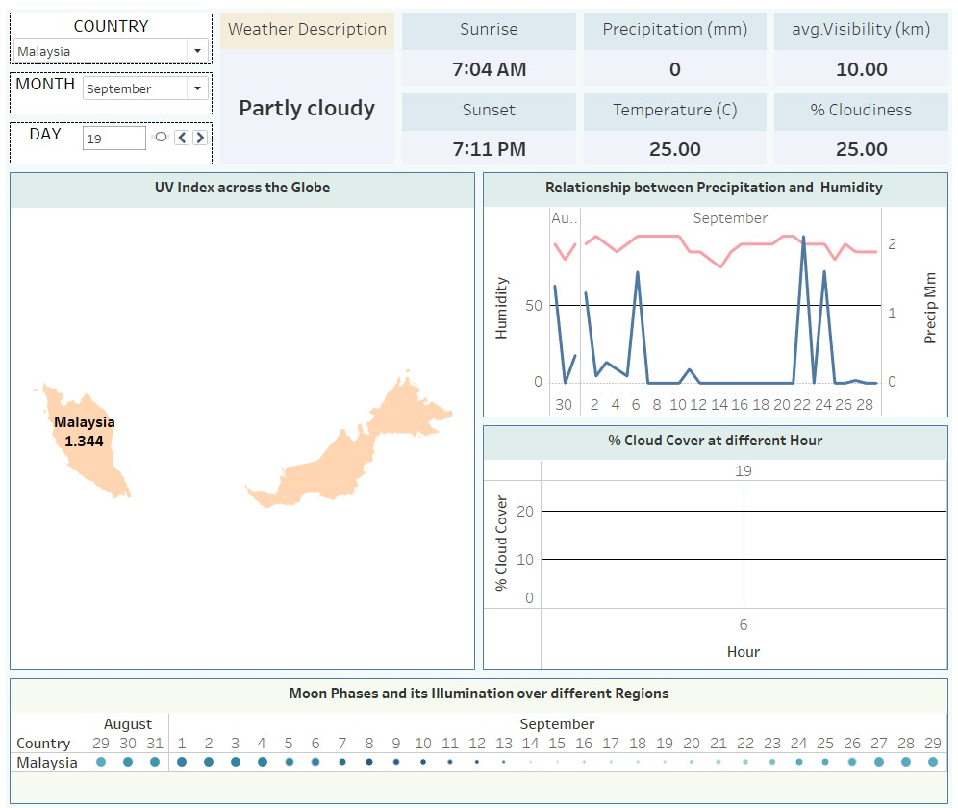

Moving on to the second dashboard, I aimed to compare the perceived temperature (feels like temperature) with the actual average temperature in different countries for specific days. Visualizing this temperature difference on a map graph has helped highlight the variations in climate perception across regions, providing insights into local climatic preferences and habits.

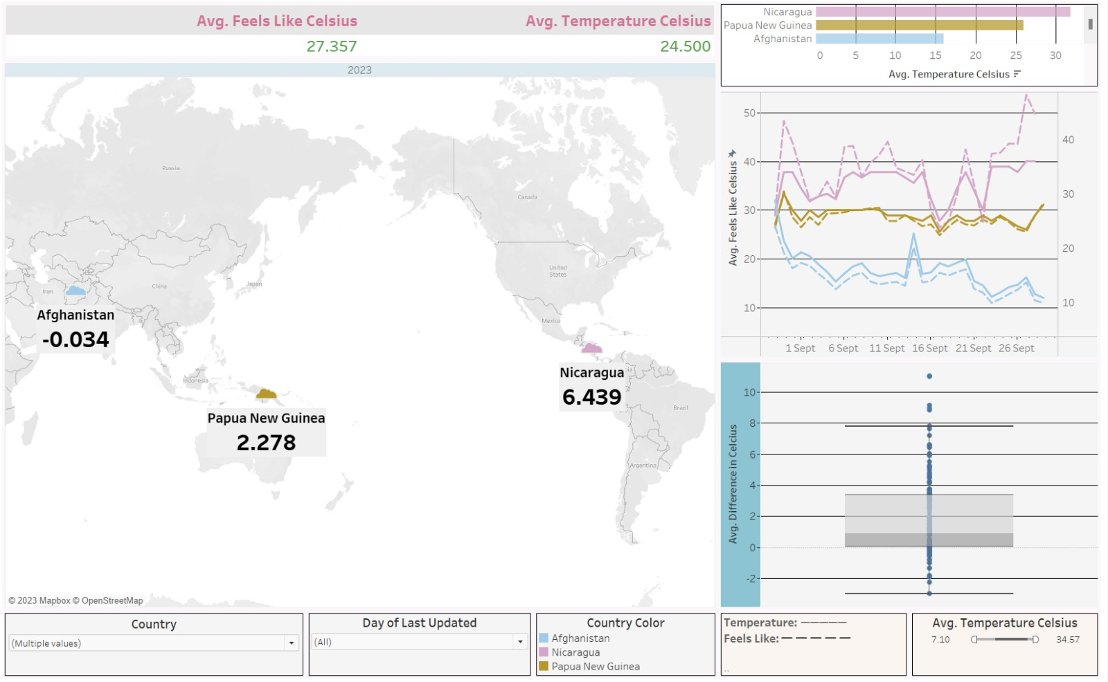

In my third dashboard, I aim to analyse wind-related parameters in various countries. The line graph highlights the relationship between wind speed and gust, providing insights into the behaviour of wind patterns. The horizontal bar chart compares different factors such as gust, wind, visibility, and their seasonal variations. The circular bar chart depicting wind speed and directions helps in understanding the predominant wind patterns in different regions. Moreover, the horizontal bar chart showcasing the top 5 time zones with the highest wind speeds offers crucial insights into regions prone to strong wind conditions.

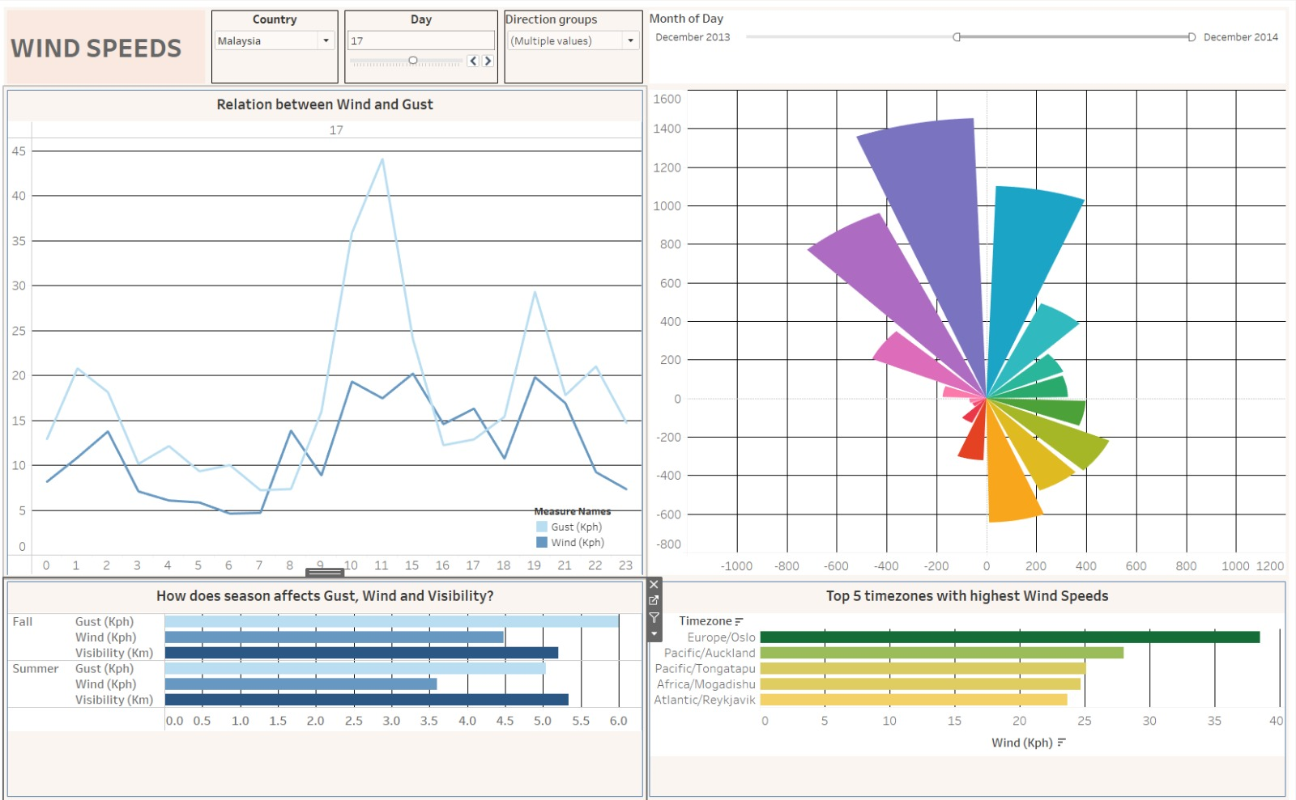

Finally, dashboard 4 concentrates on assessing air quality across different countries. It provides detailed information about the concentration levels of nitrogen dioxide, ozone, sulphur dioxide, and PM10, crucial air pollutants that significantly impact public health and the environment. The map graph highlighting the UV index and its range filter helps in understanding the regions that are potentially more exposed to harmful UV rays, allowing for targeted measures to mitigate any adverse effects.

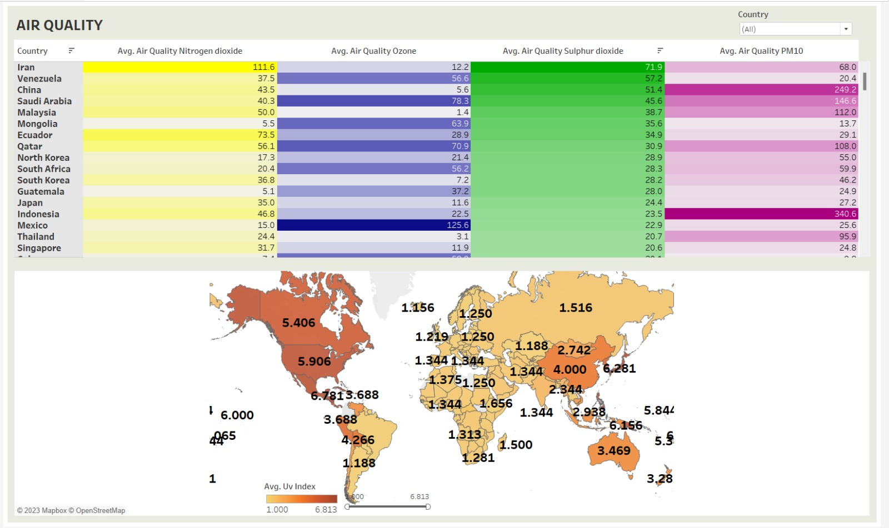

Through these dashboards, I have attempted to present a holistic view of global weather dynamics, emphasizing the interconnected nature of various weather parameters and their impact on different regions.

# Following points should be written by students:

# Create Story workspace.

# Best practices for telling best stories.

# Integrate the Dashboard and multiple sheets in story.

# Present the story as per the points considered.

# Interpret each slide of story in detail.

# Conclusion (Students should write in their own words, comparative conclusion needed):

Through this Tableau data visualization experiment, I have gained valuable insights into the art of crafting engaging narratives using interactive storyboards. I have learned the crucial aspects of creating compelling stories, integrating diverse dashboards and worksheets, and applying best practices in design, encompassing effective colour schemes, fonts, captions, and titles.

**Date: _____________ Signature of faculty in-charge**

# Post Lab Question:

# Explain the need of story in your words.

The need for a story lies in its power to transform raw data into a meaningful and relatable narrative. It serves as a crucial tool for communicating complex information in a coherent and engaging manner, enabling the audience to grasp the insights more effectively. Stories provide context and structure, making data relatable and memorable, thereby facilitating better comprehension and retention. By weaving together data points into a compelling storyline, a story not only elucidates patterns and trends but also fosters a deeper understanding of the underlying implications, driving informed decision-making and fostering a stronger connection between data and its real-world applications.